Odisha University of Technology and Research
Ghatikia, Bhubaneswar, Pin – 751029
+ Prof. (Dr.) B. P. Dash (9437385554) placement@outr.ac.in
+ Dr. S. Patnaik (9438488168)

Ref………………./ACD Date:
To
The Chief General Manager,L&D
Rourkela Steel Plant (RSP),SAIL,
Rourkela, Sundargarh,Odisha-769011

Subject: Internship during summer break in your esteemed organization from 15/06/2026 to 15/07/2026.

Sir/Madam,

I am pleased to introduce Uttam Kumar Tanty, a student of Odisha University of Technology and Research, Bhubaneswar, pursuing a B.Tech degree in Electronics and Instrumentation Engineering branch, 4th Semester (2nd Year), bearing University Regd. No. 24110764, is a bonafide student of our university. He is interested to take Internship in your esteemed organization during the summer break in 2026. He is a sincere student and bears good moral character.

Therefore, I request you to kindly consider his application enclosed herewith for the internship in your esteemed organization from 15/06/2026 to 15/07/2026.

Yours Sincerely,

Dean, Academic Affairs
Odisha University of Technology and Research

Enclosures:
- Recommendation letter
- Student bio-data
- Photocopy of University ID card
- Photocopy of any National ID card


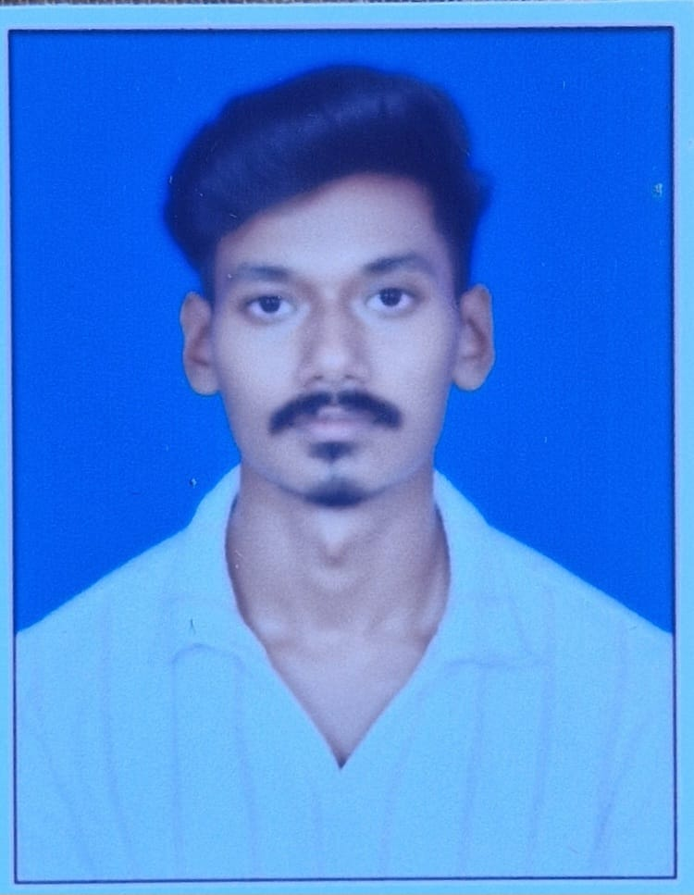
Odisha University of Technology and Research
Ghatikia, Bhubaneswar, Pin- 751029

PERSONAL DETAILS
Name | UTTAM KUMAR TANTY
Gender | MALE | Contact Number |  | 6372953131
Email ID | uttamkumartanty2004@gmail.com |  | Blood Group: O+ve

PREVIOUS SUMMER INTERNSHIP
CTTC, BHUBANESWAR | NONE
EDUCATION BACKGROUND
SECONDARY EDUCATION | 96.5% | ISPAT ENGLISH MEDIUM SCHOOL, ROURKELA,ODISHA | 2022
HIGHER SECONDARY EDUCATION | 76.5% | DELHI PUBLIC SCHOOL, SECTOR-14, ROURKELA,ODISHA | 2024
BTECH UNDERGRADUATE | 8.33 Cgpa  (upto 3rd Sem) | ODISHA UNIVERSITY OF TECHNOLOGY AND RESEARCH, BHUBANESWAR | 2024-2028
SKILLS
TECHNICAL SKILLS | - Circuit Simulation Using MULTISIM  - IOT system design and simulation using Arduino IDE and Proteus  - Signal Processing using MATLAB  - Circuit designing using SIMULINK
FUNDAMENTAL SKILLS | - C Programming  - Signal System Basics  - JAVA Programming  - Basics of Digital Electronics and logic gate operations
ADDITIONAL COURSES
APNA COLLEGE | - Web development using HTML,CSS,JAVASCRIPT and MERN STACK.
POSITIONS OF RESPONSIBILITY
ZAIRZA | - Technical Member at ZAIRZA,OUTR Bhubaneswar
ACADEMIC ACHIEVEMENTS / PROJECTS / LIVE PROJECTS
- Iot Based Fall Detection And Emergency Alert System
- Loss Of Charge Method Using High Resistance
- Detecting Cyber attack using interceptor
EXTRACURRICULAR ACHIEVEMENTS
 | - Teamwork,Leadership and participation in College extracurricular activities
LANGUAGES
ENGLISH, HINDI, ODIA

Signature of the Student

APPLICATION FOR STUDENT INTERNSHIP/TRAINING

Name of the Student | : |  |  | UTTAM KUMAR TANTY
Present Address | : |  |  | D-474,SECTOR-20,ROURKELA,SUNDARGARH,769005
Mobile Number | : |  |  | 6372953131
E-Mail ID | : |  |  | uttamkumartanty2004@gmail.com
Degree Program : B.TECH
Semester : 4th |  |  | Branch/ Specialisation : ELECTRONICS AND INSTRUMENTATION
Duration of the project training required : 1 MONTH
Proposed date of start of training : 15TH JUNE, 2026
Name and address of father : HAREKRISHNA TANTY, D-474 , SECTOR-20,ROURKELA,SUNDARGARH,769005
Particulars of the Person/HR who is related to the organisation |  |  |  |  | : | HAREKRISHNA TANTY  (JUNIOR ENGINEER)
Date: Signature of the Student
Place:

RECOMMENDATION
I certify that Uttam Kumar Tanty bearing University Regd. No. 24110764 is a student of Odisha University of Technology and Research, Bhubaneswar in the 2nd year of B.Tech in Electronics and Instrumentation branch. I recommend him for 1 Month of Internship from 15/06/2026 to 15/07/2026 at his own risk. The university shall have ‘No Liability’ whatsoever, due to the accident or mishap caused to the student during the period of Internship. Any loss or damage to the property of the organisation will not be borne by the University. No travel and accommodation expenses will be borne by the University.
Date: | Name and Signature of HOS/ HOD
Place: |  | Seal

